This challenge helps you practice computational thinking, which means learning to think like a programmer.
Challenge 1: Create a Pattern Using a for Loop
Use a single or nested for loop to generate the following pattern.
- Difficulty Levels:
  - Easy – simple pattern with a single loop without variables
  - Medium – more complex pattern, may require a nested loop
  - Hard – advanced pattern with multiple nested loops or additional logic
Goal:
- Analyze the pattern first, break it into repeating steps, then write code using loops.
- Experiment with both single and nested loops to see how the pattern is constructed.

Easy:
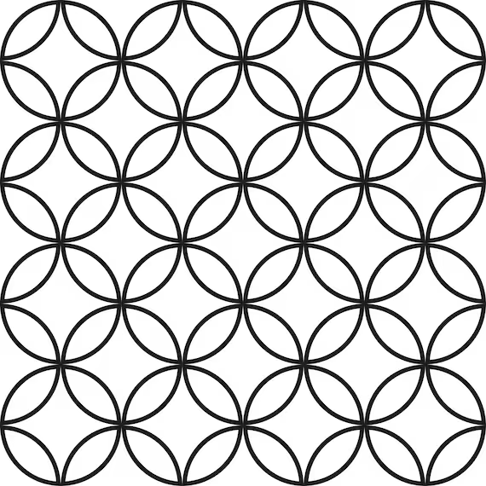
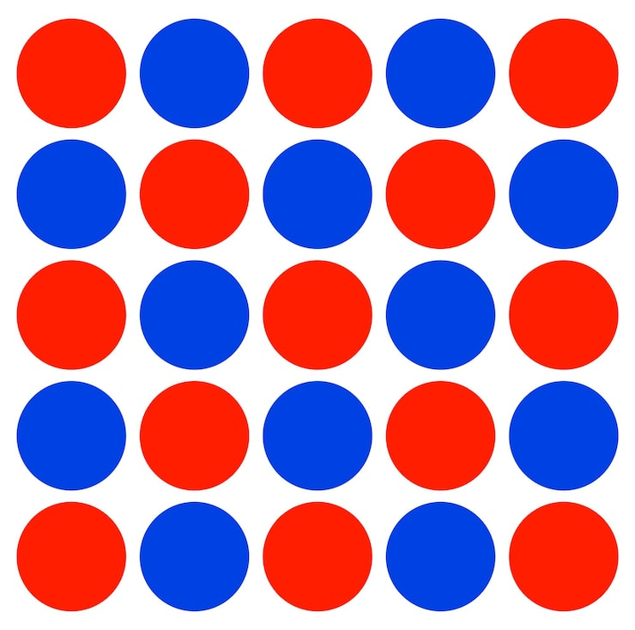
Medium:





Hard:


